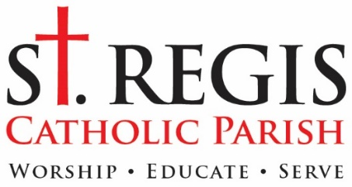
September 3, 2020

«Primary_Addressee»
«Address_Line_1»
«Address_Line_2»
«City», «State» «ZIP»

Dear «Primary_Addressee»:

Our 2020 Catholic Services Appeal is off to a great start with about a quarter of our parish families making their pledges or contributions. Their generosity has helped us to surpass the Archdiocese of Detroit mandated goal of $88,239 and move toward our parish budgeted goal of $243,239. We are now reaching out a second time to those who have not made a pledge to ask for your participation in this important campaign.
A Catholic Services Appeal donation is the ideal way to help the parish, because 100 % of every dollar directly benefits the parish with no tax taken out, and it has no effect on next year’s mandatory target. We have been able to maintain all that we do at St. Regis during the current pandemic, because of the ongoing generosity of St. Regis parish members. A successful CSA is critical to the financial health of our parish. Please join in this year’s effort.
The amount you pledge is, of course, up to you. Many people have asked what amount is recommended. I have asked, if possible, for people to consider a gift of $500. Some can give significantly more; some might need to give less. I realize that financial circumstances have changed for many. What I ask is for you to take time to thoughtfully consider your donation and do the best you can.
To make a CSA pledge, please fill out the form below and return it via U.S. mail, drop it in the collection basket at Mass, or stop by the parish office. You can also pledge online at stregis.org/donations. If you have questions about the CSA you can find answers on our website, or feel free to contact me at the parish office. If for some reason we have made a mistake and you have already made your CSA pledge, please excuse this letter.
Over the last few years Archbishop Vigneron has challenged Catholics of the Archdiocese of Detroit to “Unleash the Gospel.” I believe St. Regis is well-poised to do that, both in its current ministries and in ones that will emerge over the next few years. Your generosity to this yearly appeal helps ensure that the parish is financially able to live up to that challenge. Thank you.
God be with you.
Fr. David Buersmeyer
Pastor

«Primary_Addressee»
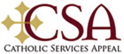
«Address_Line_1»
«Address_Line_2»
«City», «State» «ZIP»

My pledge to the 2020 Catholic Services Appeal is $ ___________

___________ My check is enclosed. Please make check payable to Catholic Services Appeal.

___________ Please have the Archdiocese of Detroit bill me later.
□ Gave by Credit Card or Bank EFT Online (call 1-888-331-8695 between
9am-5:30pm M-F)
□ Monthly Payments (Starting in October)
□ Quarterly – October/January/April

PLEASE MAKE ALL CHECKS PAYABLE TO: CATHOLIC SERVICES APPEAL.

