

Due to the pandemic crisis, SOS will continue their efforts to shelter their guests in place at a local Oakland County hotel. St. Regis will continue to support SOS this year through fundraising efforts to help their guests continue to shelter in place as they are caring for more guests than ever before. Our fundraising goal is $20,000 which will provide room and board for 120 guests from June 13 – 19.

To donate, please buy a SOS/St. Regis branded hoodie or T-shirt [**LIMITED EDITION Tie-Dye or Navy T-Shirt**](https://na01.safelinks.protection.outlook.com/?url=https%3A%2F%2Fshop.stregis.org%2Fcollections%2Fnjhs-limited-edition-support-sos-shirts&data=04%7C01%7C%7C992154dc64bc4a506b8a08d90385d650%7C84df9e7fe9f640afb435aaaaaaaaaaaa%7C1%7C0%7C637544695637121414%7CUnknown%7CTWFpbGZsb3d8eyJWIjoiMC4wLjAwMDAiLCJQIjoiV2luMzIiLCJBTiI6Ik1haWwiLCJXVCI6Mn0%3D%7C1000&sdata=H0x6cGyV3yIWIMuer%2BN9MlNuGR%2BmSlTu5KBHYXVi21E%3D&reserved=0)

or go to St. Regis website, <https://stregis.org/sos/>

God be blessed for your generosity.

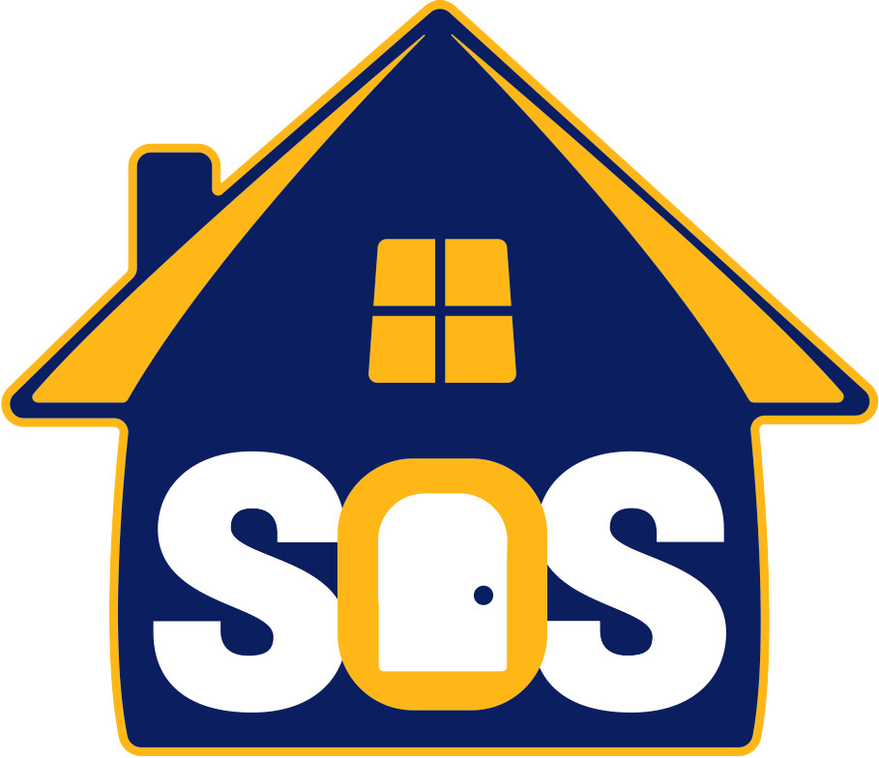

Your donations are needed to make this week a successful and memorable experience for our guests.

**Lend A Hand!**

**South Oakland Shelter**

**June 13-19, 2021**