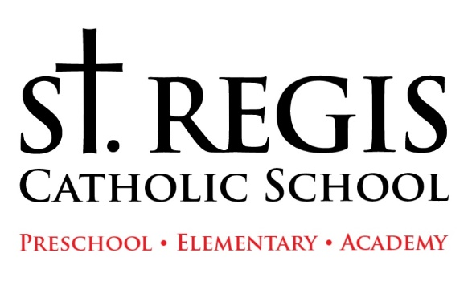
St. Regis Catholic School
2021-2022 Tentative School Calendar
(All Dates Are Subject to Change)
Week of August 16: Academy Orientation Days
August 22: Parish/Back to School Picnic 1:00PM
August 23: 1st day for Students Half Day (Pk-8)
August 24: Half Day (Pk-8)
August 25-27: Half Day Pk, Y5, and Kindergarten
August 25-27: Full Day 1st through 8th
September 3: School Closed
September 6: School Closed: Labor Day Holiday
October 18: No School-AOD Professional Development Day
October 22: Last Day 1st Quarter
October 27: Half Day-Conferences
October 28: Half Day- Conferences
October 29: School Closed Professional Development Day
November 1: All School Mass: All Saints Day
November 24-26: School Closed: Thanksgiving Holiday
December 8: All School Mass: Immaculate Conception
December 20-31: School Closed: Christmas Break
January 3: School Resumes
January 14: Last Day 2nd Quarter
January 17: School Closed: MLK Holiday
January 31-February 4: Catholic Schools Week
February 21-25: School Closed: Mid-Winter Break
March 2: Ash Wednesday
March 14: No School: AOD Professional Development Day
March 25: Last Day 3rd Quarter
April 14-22: School Closed: Easter Break
May 30: School Closed: Memorial Day
June 3: Last Day-Half Day

