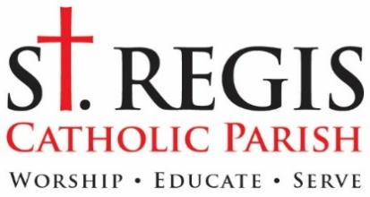

April 24, 2023

Dear Member of St. Regis:

The 2023 Catholic Services Appeal has begun with the theme Go and Announce the Gospel of the Lord. As Catholics we share an experience of Church in both the local parish and the larger community of the Archdiocese of Detroit. Both experiences are essential to participating as a Catholic Church in the mission and ministry of Jesus. The C.S.A. is our yearly experience on a very practical, financial level for helping our Archdiocesan community and ourselves live up to the call to form missionary disciples of Jesus, and to serve our brothers and sisters. Through the C.S.A. we help over 170 different programs and ministries maintain their outreach and mission, including: college campus ministry, marriage and family ministry, programs for the handicapped, Catholic religious education, parish life programs, and much more.

As you may know, the Archdiocese of Detroit gives every parish a mandated C.S.A. target. Every parish must meet this target through its parishioners’ C.S.A. donations or pay the shortfall out of parish operating or savings funds. The great news is that 100% of monies donated above our target come back to St. Regis “tax-free” for our own use. This coming year those extra monies will be used to continue to beautify our church entrance area, help with the cost of new windows in the school, and allow us to maintain a strong and dedicated parish staff to serve the parish. We are grateful for every gift!

Knowing that we will exceed our target every year and that such monies directly benefit St. Regis Parish, a number of parishioners use the annual C.S.A. to give significant gifts to the parish. Consider whether that is a possibility for you, as you think about this year’s contribution. Also included with this letter is a C.S.A. “Myth and Facts Sheet” to review some of the common questions people have about the C.S.A. As you read over the materials, please do not hesitate to call me or the business office for any additional information you may need.

How much should you give? I know that financial situations vary greatly, but I ask that every parish household prayerfully consider a generous gift. The card prepared by the Archdiocese has a box for “Other”, and I hope most of us can check that box and offer a gift of at least $500. Some are able to give significantly more, some less. If most of us, myself included, give a generous donation we will be able to meet all our obligations.

Please place the enclosed donation card in the envelope and mail it directly to the processing center address or drop it in the collection at any Mass and we will mail it. On the back of the pledge card, you will find information on how to give online or by credit card, if that is more convenient for you. If you choose to donate through the Archdiocesan website, be sure to select St. Regis Parish as the recipient of the gift.

Thank you for your continuing support. St. Regis Parish needs it and I truly appreciate it. If possible, we ask that you make your C.S.A. pledge within the next few weeks, or by May 24th. If you are financially unable to contribute this year, just mark the pledge/donation section with a “0” and return it. We then know we do not need to contact you further or send you a follow-up letter. Thank you.

Sincerely,
Fr. David Buersmeyer
Pastor

